Exercise
1
a)
H₀: Customers choose each type of snack with equal probability.
H₁: Customers do not choose each type of snack with equal probability.

b)
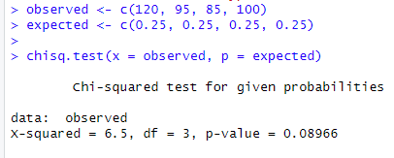

c)
H₀ states that all snack types are chosen equally with 0.25 probability. The p-value = 0.08966, which is higher than the significance level of α = 0.05. Therefore, we do not reject H₀.

